**Final Report Template**

# Professional Resume : Software Developer

## 1. Introduction

* This high-quality personal website will serve as both portfolio and resume of a software developer that **strikes the perfect balance** between creative and professional.
* First of all, it’s super user-friendly. It will tell end-user’s personal story with interesting graphics and icons, using a **perfect color scheme**. Navigation through Profile,

Experiences, Abilities, Projects, Work experience, Skills, Contact and About me pages is perfectly smooth and it’s an incredible thing to do, as it will give accurate info about enduser’s work. Also it also helps in digital marketing and promotions of the end-user’s work.

### 2.Design and Implementation

* The site will most likely include the following features : Profile, Experiences, Abilities, Projects, Work experience, Skills, Contact and About me pages.
* By having these features visitors of website can get to know about end-user’s work, skills, experiences , contact information etc. about the end-user.
* To convert my project from design to the actual realization in terms of implementing the code I have used various css and javascript properties using bootstrap classes , which made my website more dynamic and interesting.

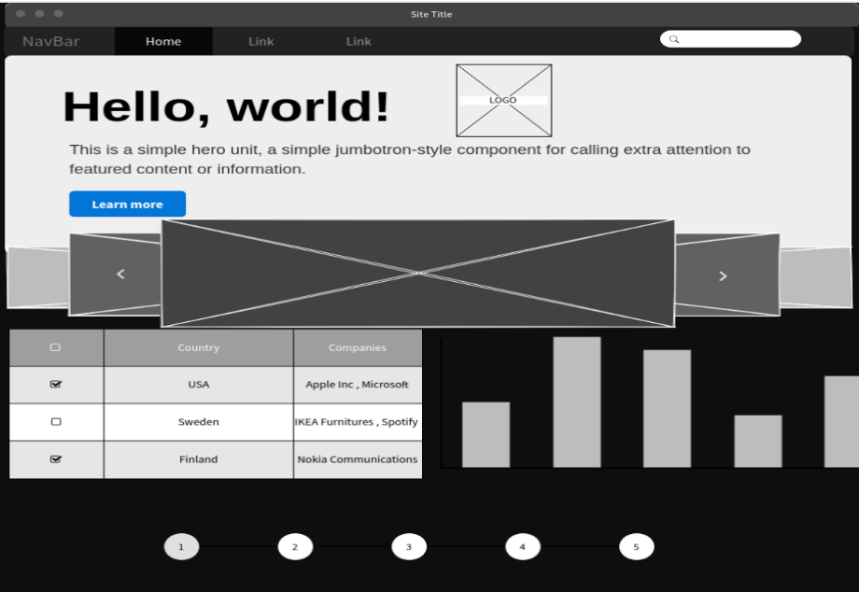

### 3.Conclusions

* Outstanding results are obtained from the project, which includes social recognition, online promotions and advertisements.
* All the features are enlisted in the above section, but for shortcomings ,I want to say

that design and graphics are much simpler, that should be more interesting.

* It is not the exact idea behind my website , but it’s the somewhat graphical presentation of it , which can be changed too. And which includes way more features, but somewhere design can be similar to this.

## 4. References

• All the reference webites are given below :

* + <https://www.rachelebsmith.com/> - Brooke Smith(Fitness Trainer)
  + <https://andrevv.com/> -Andrew MacCarthy(Designer)
  + <https://gruev.space/> -Vladimir Gruev(UI/UX Designer)
  + <https://www.justinbiebermusic.com/> -Justin Bieber(Singer)
  + <http://www.jackiechan.com/> -Jackie Chan(Actor)